**Chord Progression Network Analysis of Ray Charles Songs**

**Team 09: Gehan Velivitiya & Juanita Ramirez**

**CNT5805: Final Project Report**

1. As a basis for understanding our project, it is necessary to define the following musical terms:  
   **Note:** The elementary unit in music. There are 12 unique notes ordered: 0-1-2-…-11, denoted by: C - C# (=Db) - D - D# (=Eb) - E - F - F# (=Gb) - G- G# (=Ab) - A - A# (=Bb) - B. Some notes have two names.

**Chord:** Three or more notes played simultaneously. For example, C-chord = {C-E-G}. The chord name varies depending on the distances between the notes that compose the chord. Some examples are: C, Cm, C7.   
Remark: notes and Major chords have the same name, but the context differentiates them.

**Chord Progression:** Group of chords played consecutively, for example C-G-Am-F. Chord Progressions form the harmonical structure of songs[1].

In this project, we constructed a chord progression network based on chords extracted from Ray Charles songs in the website: <https://www.e-chords.com/ray-charles>. The nodes are the chords and the links connecting the chords of the song in an orderly fashion. For each pair of nodes, there is a source chord and a target chord, it is a directed and weighted graph, and the weight indicates in how many songs the transition occurred. The network has 167 nodes and 1246 edges. All the chords were transposed to the keys Major C and to it’s relative Am, in order to preserve similarities in distances among all the songs.

The inspiration behind the project was to analyze basic musical concepts like orders between notes (Scales and the Circle of Fifths) that lend themselves well to graph representations. This project aims to generate complex graphs for songs and seeks to clarify which patterns music follows, what structural characteristics it has, and how these structures influence the songs of Ray Charles, an influential musician in Soul and Jazz.

**Research Questions:**

1. Nodes and link attacks could represent failures in the instrument or the person playing it. Can the chord progression network show why some mistakes in songs go unnoticed? What is the robustness of the network?
2. Does Ray Charles have a unique music style compared to other artists?
3. In the structure, why do more important links (larger weights) appear?
4. Does Ray Charles have a preference for chords used in his songs?
5. Are there any communities? Is there homophily? Is it possible to explain those communities using music theory?

In summary, these questions cover a range of topics related to the uniqueness of Ray Charles’s songs and network attributes such as communities, homophily, robustness, the prominence of high-weighted links, and the appearance of hubs.

1. **Initial Graph and Statistics:**

*Fig 2.1: Initial graph of Ray Charles song chord progression network.*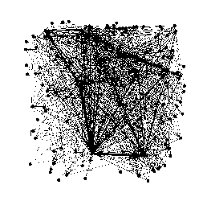

This is a weighted and directed graph with 167 nodes and 1246 edges.

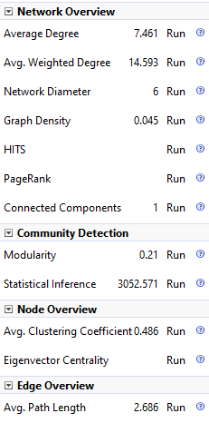

*Fig 2.2: Screenshot of statistic panel for Ray Charles song chord progression network*

The network appears to be fully connected. It is observable that towards the center there are few hubs and heavy weight edges among them. One of them may be the key of the song (C or Am) and the rest could be frequently used chords by Ray Charles in his songs. However the information gathered from the initial graph is very limited and vague.

1. **Dual Circle Layout:** 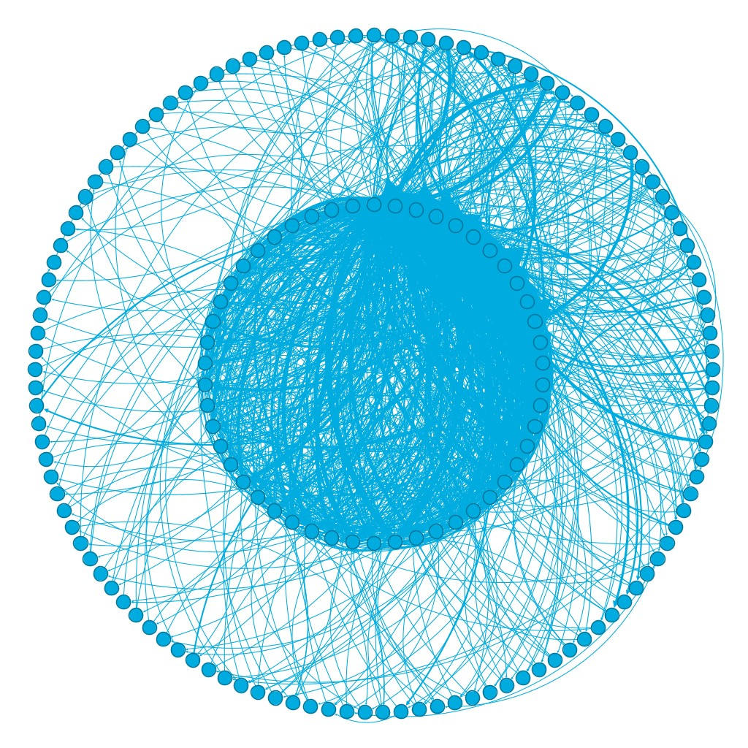

*Fig. 3.1: Dual Circular layout based on degree of the node.*

In this layout nodes are ordered in two circles (inside and outside circles), based on their degree in clockwise direction. Nodes with higher degree are positioned in the inside circle and it is observed a high density in the inner circle compared to the outside circle.  
  
It means that there are common chords and rare chords, common chords are repeatedly used among all songs, rare chords which have a different sound apport variety to the songs but are not used repeatedly among all songs. In the graph there is a greater quantity of rare chords than common chords, it could indicate that a majority of songs have a small amount of rare chords and rare chords tend to be unique, contributing to the distinctive sound of each song.

1. 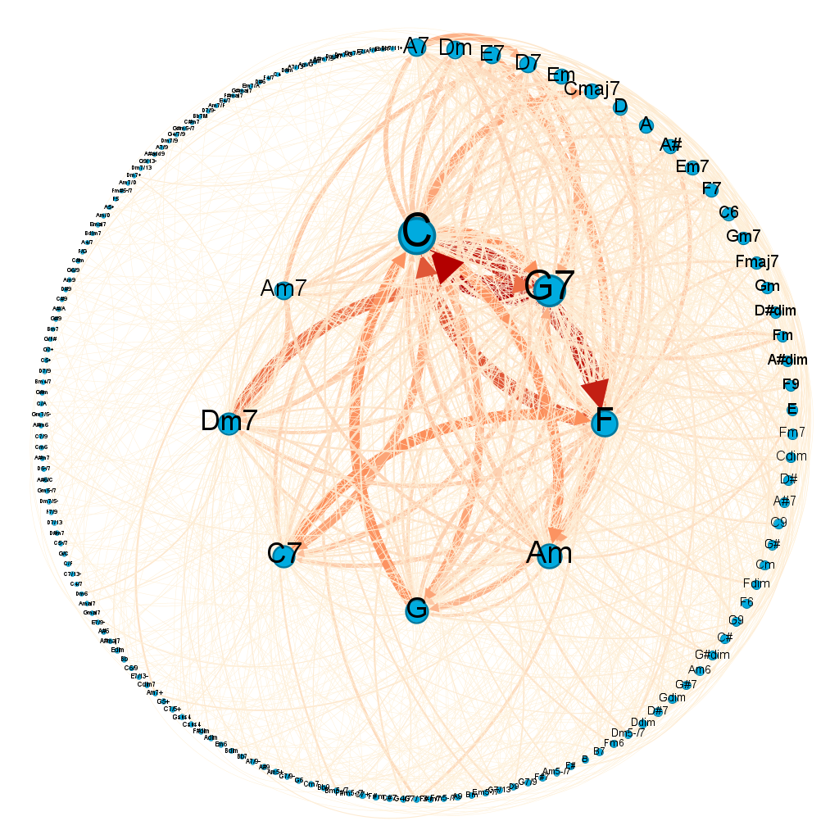

*Fig 4.1: Ray Charles chord progression network incorporating color and size to emphasize edge weights and node degrees.*

With the emphasis added to the degree and weight attribute in the network it reflects more information than the raw graph. Now we can clearly see the hubs in the network. Eight higher degree nodes are positioned in the inner circle. Also, the weight of edges among these higher degree nodes are comparatively larger than the rest. The node with the highest degree appears to be “C”, and this makes perfect sense as chord “C” is the key of the majority of songs and progressions tend to start and end in the key. Next it is “G7”, “F” and “Am”, Am was also expected to be a hub because it is the key of songs composed in minor scale.

When looking at the edge weights it is observed that there is a heavy weighted connection between “C” and “F” and “C “ and “G7”. Apparently the edge from “C” to “F” has a higher weight than from “F” to “C” meaning there is a dominant direction between the nodes. In conclusion the hubs of this network are densely connected among them but also those connections are heavy weighted links indicating a repetition of common chord progressions for all the songs.

1. **Statistics:**  
   The **average path length** is 2.686 and the **network diameter** is 6. Several nodes have a high **betweenness centrality** but the majority have a low betweenness centrality, the same occurs with the **closeness centrality** distribution this explains why the average path length is small while the diameter doubles it.  
   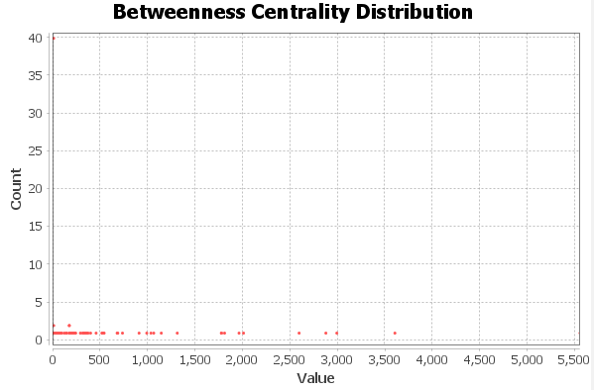

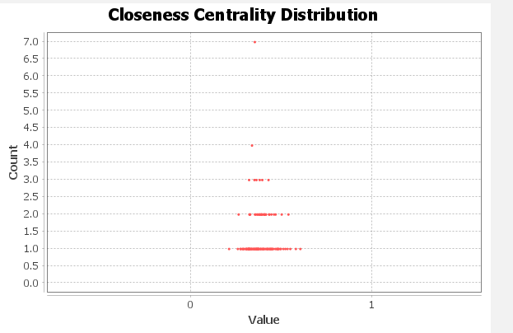

**Clustering Coefficient Distribution and Density:** The clustering coefficient and the density of the graph are different, while the density is 0.045, the clustering is 0.486. This offers insights into the connectivity of the graph, while only 4.5% of possible connections appear globally, on average for each node 48.6% of neighbors are connected between them.

**Degree Distribution:** This network has a long-tailed scale-free distribution. The average degree is 7.46 and the minimum value in the distribution is 2 and the maximum is 130.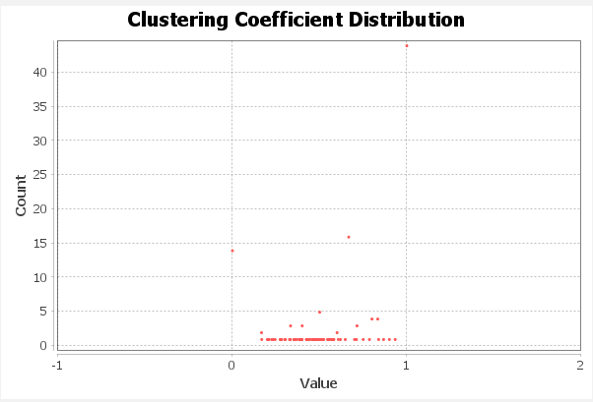

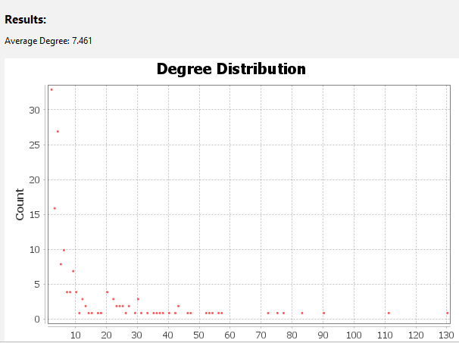

*Fig 5.1: Degree distribution for the chord progression network in log-log scale, in the left plot the network is considered undirected and in the right plot the network is considered directed.*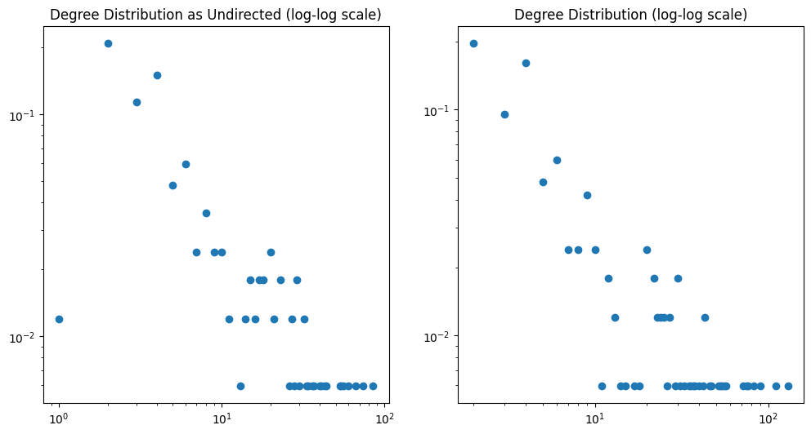

The comparison between the distributions in the directed and undirected network, let us visualize that most of the nodes with lower degree are connected with two distinct nodes (Ex: Chord1→Chord2→Chord3) instead of a bi-drected link between two nodes (Ex: Chord1→Chord2→Chord1), and because k_min=2 we can deduce that most of the rare chords are part of cycles which are very common in music, and contribute to the chord progression flow in the graph (This affirmation is proved in point 7 when robustness is analyzed ).

To summarize, these statistics show a difference between the inner and outer circles of the layout, the inner circle nodes have a high density, high degree, and high betweenness centrality while the nodes in the outer circle show a low density, low degree, low betweenness, and possibly low clustering coefficient. These strong differences could act like outliers in the distributions of the measurements affecting the average statistics of the network.

To deepen the understanding of how the inner graph affects the degree distribution and clustering coefficient, the Ray Charles Chord Progression Network was compared with a Random Graph and a graph constructed with the Albert Barabasi Model, with a Spiral Layout.

*Fig. 5.2: Ray Charles Graph in Spiral Layout based on degree (higher degrees nodes are in the center of the spiral)*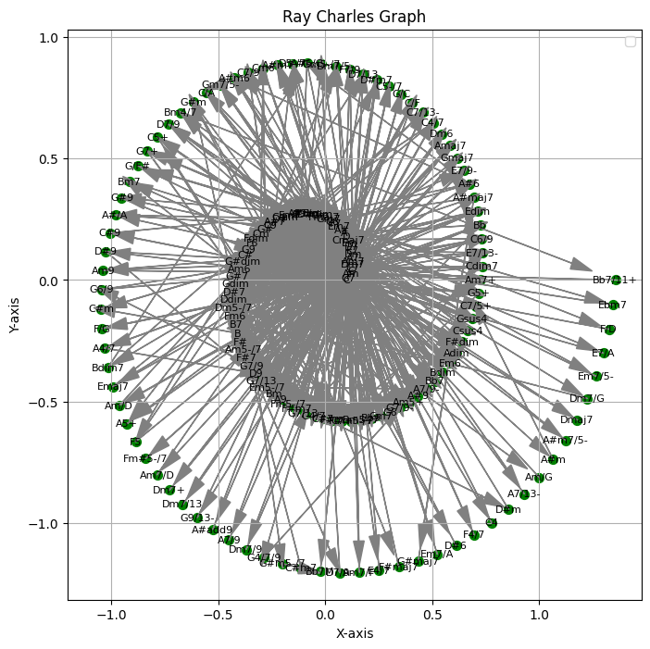

The Spiral Layout gives insights into why the average path length is 2.6, most of the chords on the outside of the spiral point to the center of the graph, and the center is densely connected. When connecting two rare chords (R), the shortest path would possibly be R1-C-R2 or R1-C1-C2-R2 (with C representing common chords). Then the shortest path length is between 2 and 3.

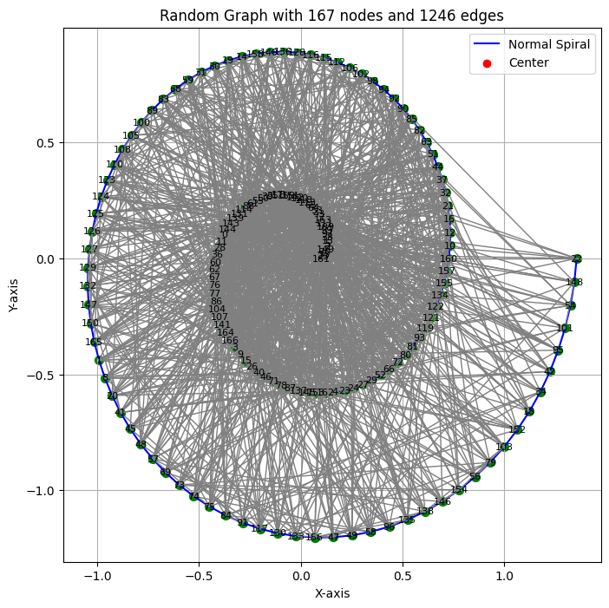

*Fig. 5.3: Random Graph with Spiral Layout based on degree.*

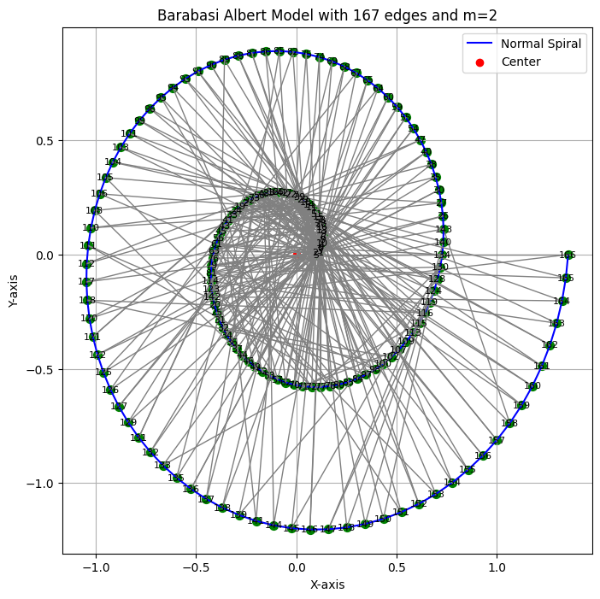

*Fig. 5.4 Albert Barabasi Graph with Spiral Layout based on degree, m refers to the degree to which new nodes join the graph with preferential attachment.*

The Random Graph was considered to have the same number of nodes (N) and edges (L), while the Albert Barabasi Graph has 167 nodes and 330 edges, m was taken as two because most of the nodes in the Chord Progression Network have k=2.

| Graph | N and L | Density | Avg. Clustering Coefficient | Avg. Degree |
| --- | --- | --- | --- | --- |
| Fig. 5.2 | N= 167, E= 1246 | 0.0449 | 0.486 | 7.461 |
| Fig. 5.3 | N= 167, E= 1246 | 0.0898 | 0.0904 | 14.9221 |
| Fig. 5.4 | N-167, E=330 | 0.02380 | 0.0508 | 3.9520 |

In comparison, all of the graphs have a low density. The Chord Progression Network is very distinct from other graphs in its average clustering coefficient; it might indicate a density close to one in the inner circle and a high amount of closed triangles in the outer circle. The average degree lies between the graphs in Fig. 5.3 and Fig. 5.4, but is closer to Fig. 5.4 indicating that the high amount of rare chords with low degree affect the average degree.

An interesting feature in Fig 5.2 was the number of edges compared to Fig 5.4, for the Spiral Layout Fig 5.2 resembles the Albert Barabasi Graph more than the random graph, but this graph only contains 26.4% of the amount of edges that the Chord Progression network has, this layout emphasize the high amount of edges between the hubs.

All these results give us a better understanding of the dynamics between rare and common chords and are useful for the comprehension of chord progression flow and structural patterns.

1. 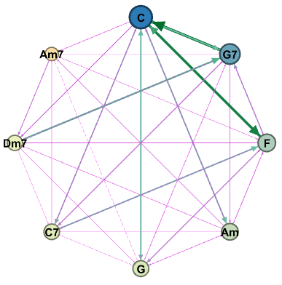

The nodes were filtered based on their degree. By doing so the inner circle of the network

in Fig 4.1 is isolated. It appears to be complete and fully connected. The density of the directed graph is 0.929 and the undirected graph is 1. The average clustering coefficient is 0.929. These are the most common chords played by Ray Charles in his music. The dominant edge from “C” to “F” can be clearly observed here. The reason for these dominant edges will be discussed later in this document. Looking at patterns which can be clearly seen in this network, there are cycles like “C” to “F”to “G7” and back to “C”. This shows possible harmonies in songs.

*Fig 6.1: Filtered inner circled of Ray Charles network.*

To identify the second most prominent inner circle nodes the previous nodes(shown in Fig 6.1) were filtered out based on degree. The first noticeable factor of this filtered network is that it is not complete and the density is 0.518. The weights of these edges are fairly low compared to the most prominent chords elucidating the descending order in which chord progressions are used among the songs.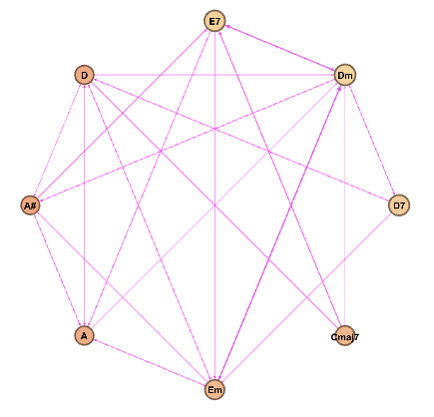

*Fig 6.2: Filtered second prominent inner circle of Ray Charles network.*

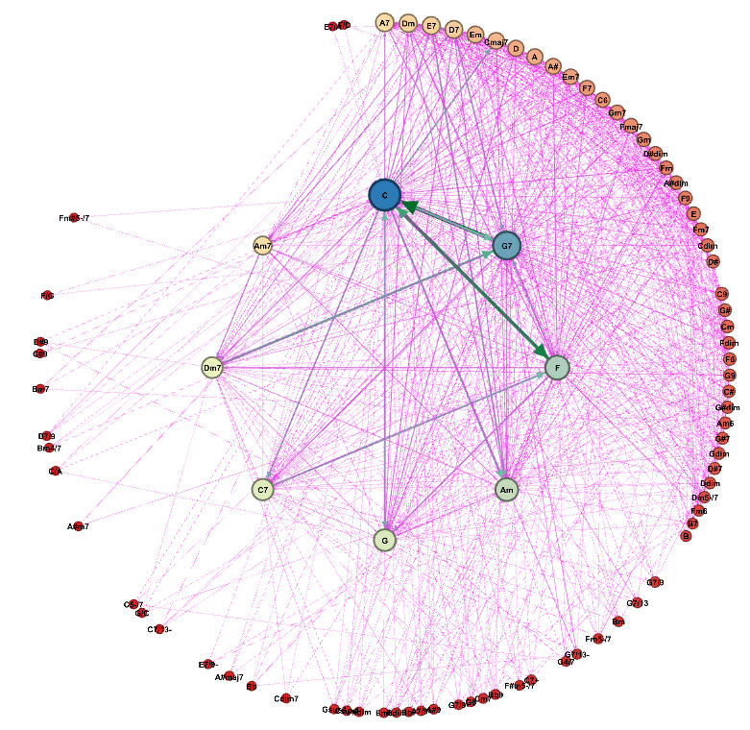

Applying the ego network filter on chord “C”, it appeared that 51.49% of the nodes are connected to it and 73.43% of edges are directed out or in, to it. Some of those edges connecting nodes are the ones with higher weights. This relays the usage of chord “C” in many chord progressions rather than it just being the key of the songs.

*Fig 6.3: Ego network filter on node C at depth 1.*

1. 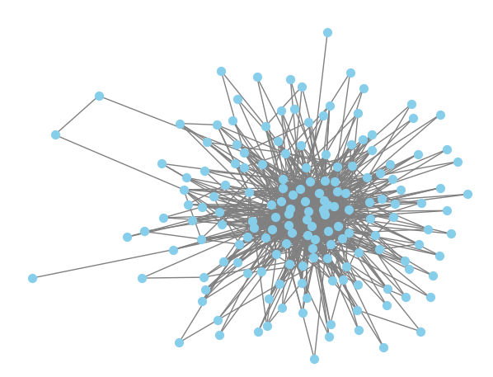

**7.1 Robustness:**

To calculate the robustness of the network, this network was considered directed and undirected, and comparisons between the measures of robustness were made.

As undirected, this network has 167 nodes and 981 edges.

**Node Failures:**

* When nodes are removed randomly, it is observed that the undirected and directed graphs are close to the diagonal. The amount of nodes in the giant component is similar to the number of nodes in the graph minus the removed nodes, which means that it is not possible to disconnect the graph in several connected components. Despite the removal of nodes, the giant component remains connected.

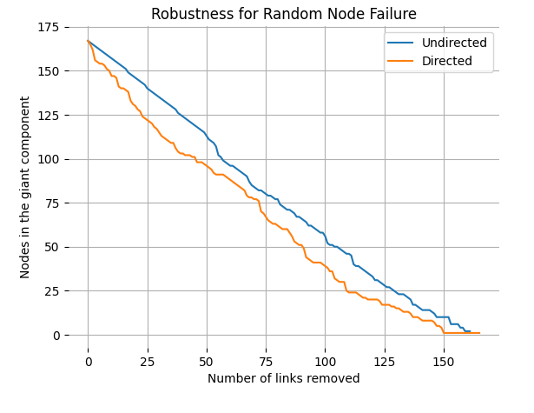

* The critical threshold for both graphs is similar, for the directed is 0.97, and for the undirected is 0.96 indicating that to break the giant component 97% of the nodes have to be removed.
* The directed network is less robust than the undirected network, the difference in robustness is related to the fact that for undirected graphs the number of nodes in the largest connected component is taken as the y-axis, instead for directed graphs the number of nodes in the largest *strongly* connected component (SCC) is taken as y-axis.

An SCC is a subgraph where for each pair of nodes (A,B) there is a directed path from A to B and from B to A. The presence of a SCC allows information to flow within the graph, for this network, there is a chord progression flow.

This result indicates that the network has a high robustness for node failures.

**Link Failures:**

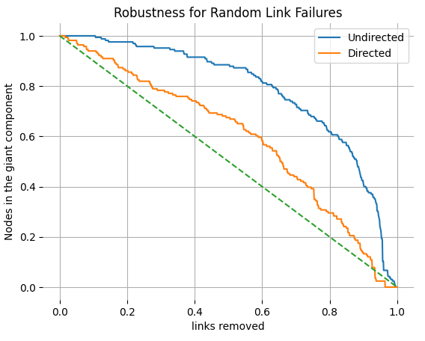

* Random links were removed from the graph and it is observed that for 80% of links removed around 60% of nodes belong to the giant component in the undirected graph, meanwhile, in the directed graph the information flow was affected, and after 80% of nodes removed around 30% of nodes belong to the SCC.
* After 50% of random links removed, even though the directed graph seems more connected, the number of nodes in the SCC is 121, and the number of nodes in the connected component for the undirected graph is 154.

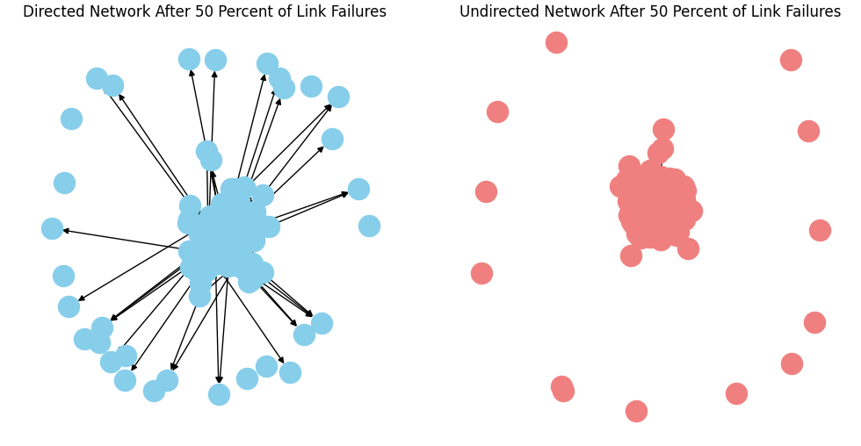

Conclusion: The chord progression network is robust for node and link failures, the threshold is near to one for random node failures. The comparison was useful to understand why a directed network that has more links and seems more connected could be less robust than an undirected network with less number of links, and how failures in rare chords impact the chord progression flow .

**7.2 Communities:**

There is one giant connected component according to statistics. This is evident by looking at the first dual circle layout diagram, where it looks heavily connected in the center circle and spreads out multiple edges connecting outer circle nodes to it.

* *Louvain algorithm:*This algorithm randomly orders nodes to optimize the modularity of the network. Afterwards it assigns nodes to other communities as long as it makes sure the modularity of the system does not increase significantly. For finding modularity class the OpenOrd layout was used, as it is better at identifying communities. Modularity at resolution 1.0 identifies 5 communities and at 2.0 it identifies one giant community. The result at resolution 2.0 seems to be more plausible as all the songs start with the same key and as we saw in previous results the graph is well connected with the possibility of forming one community.

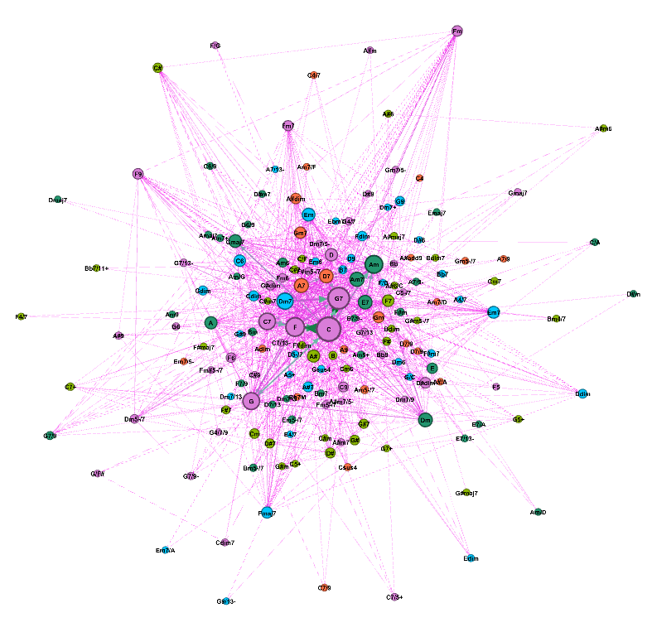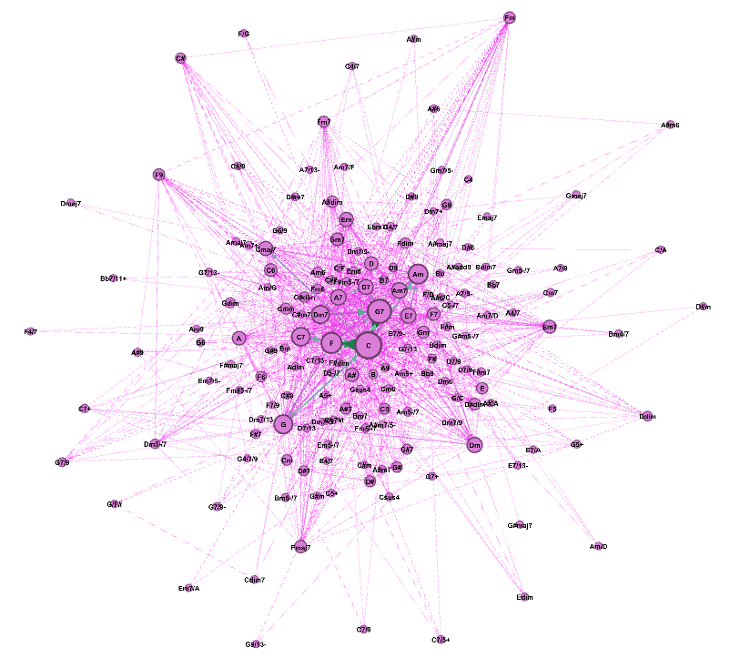

*Fig 7.2.1: Partitioned nodes in Ray Charles Fig 7.2.2: Partitioned nodes in Ray Charles*

*network by modularity class with OpenOrd layout network by modularity class with OpenOrd layout*

*and resolution 1.0 and resolution 2.0*

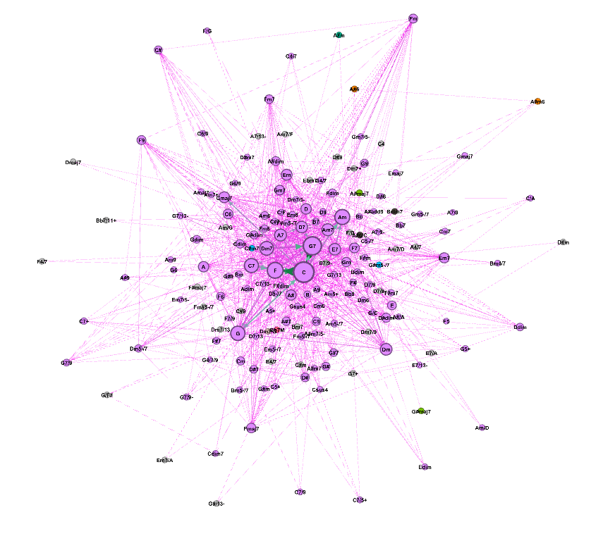

* *Girvan-Newman Clustering****:*** This algorithm is considered to be more accurate. The approach is to remove edges with high betweenness centrality to identify clusters. As edges with high betweenness centrality perhaps are local bridges between communities.

This resulted in identifying 37 clusters, however there is a single cluster with 76.05% of the nodes and the rest have 1.2% or less. This also indicates that almost all nodes forming one extremely giant cluster except for a few small clusters.

*Fig 7.2.3: Partitioned nodes in Ray Charles network by cluster ID obtained from Girvan- Newman method.*

**7.3 Jaccard Similarity coefficient:**

The Ray Charles graph (Fig 4.1) and Ray Charles Jazz Genre graph (it is the Ray Charles Graph filtered based on genre) (Fig 7.3.2) were individually compared with the general Jazz graph (Fig 7.3.1).

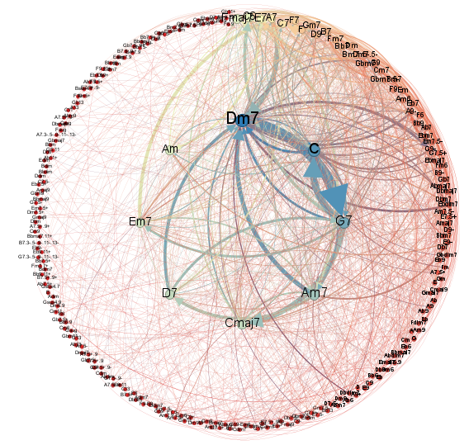

*Fig 7.3.1: General Jazz graph. This is a directed weighted network with 239 nodes and 1538 edges. Extracted from 149 Jazz Songs transposed to keys C and its relative minor Am.* [3]

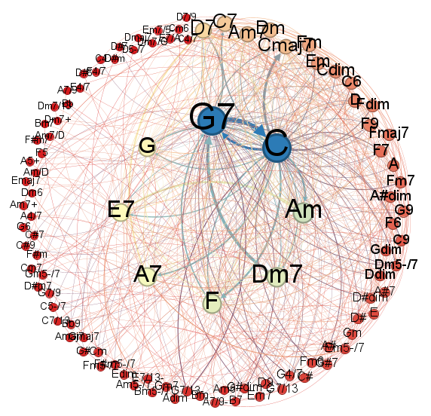

*Fig 7.3.2: Ray Charles Jazz genre graph. This is a directed weighted network with 102 nodes and 596 edges.*

* The proportion of edges in the intersection of the Ray Charles graph and General Jazz graph to that of edges in the General Jazz graph was 0.182 (281 edges belong to the intersection).
* The proportion of edges in the intersection of the Ray Charles Jazz Genre graph and General Jazz Graph to that of edges in the General Jazz Graph was 0.111 (172 edges belong to the intersection) .
* The proportion of nodes in the intersection of the Ray Charles graph and General Jazz graph to that of nodes in the General Jazz graph was 0.255 (61 nodes belong to the intersection).
* The proportion of nodes in the intersection of the Ray Charles Jazz Genre graph and General Jazz graph to that of nodes in the General Jazz graph was 0.213 (51 nodes belong to the intersection).

By looking at the edges proportion it is evident that Ray Charles has a considerably large number of unique edges, meaning unique chord progression that hasn't been used in the songs of general Jazz graph. However, looking at the proportion of nodes, about 50% of the chords in the Ray Charles Jazz Genre network are present in the general Jazz network. Having this in mind the jaccard similarity metric was used to identify the similarity between these common nodes in the two graphs.

.

First similarity study was conducted using Jaccard similarity score[4]. Typically Jaccard similarity is used to compare the similarity of two nodes in a network by calculating the proportion of common neighbors to all neighbors. The score value lies between 0 and 1, where a value closer to 1 means it has a higher similarity.

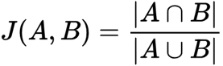

Here Jaccard similarity between node A and node B is calculated by dividing the intersection of neighbors of A and B by the union of neighbors of them.

First, the nodes in the intersection were identified (which are the common chords between networks). For each node the corresponding neighbors were identified in each graph. Afterwards the jaccard score for each node is calculated based on the formula above. Finally to get the overall jaccard similarity score the average of scores of individual nodes were taken. This average gives a holistic view of the overall similarity between the networks.

* The average jaccard similarity score between Ray Charles network and General Jazz Network was 0.149
* The average jaccard similarity score between Ray Charles Jazz Genre network and General Jazz network was 0.135

**7.4 Comparing inner circles of the three networks:**  
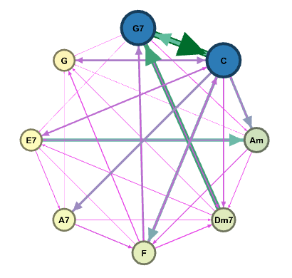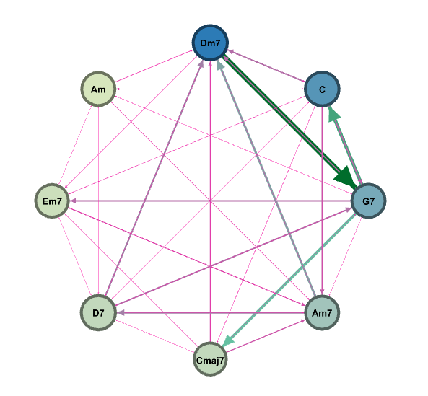

*Fig 7.4.1: Filtered Inner circle of Ray Charles Jazz Fig 7.4.2: Filtered Inner circle of General Jazz*

*network based on degree network based on degree*

Comparing Fig 6.1 and Fig 7.4.1 the nodes in the inner circle are the same, since they are Ray Charles and the Ray Charles Jazz genre graphs. Comparing Fig 6.1 and Fig 7.4.1 with Fig 7.4.2 it is visible that some chords are common like “C” (Since it is the key), “Am”, “G7”. One of the prominent chord progressions from “Dm7” to “G7” can be seen in all three networks. Another significant observation is that the majority of chords in the inner circle of the Ray Charles network are major chords whereas in the general Jazz they are minor chords. Major chords sound happy while minor chords sound sad. This says that Ray Charles tends to use chords sounding bright and happy than others.

**7.5 Circle of Fifths:**

The circle of fifths is used to look at the harmonization of the chords, all the chords in the outer circle have a distance of seven to the adjacent chords, and chords close to each other tend to harmonize well while distant chords are different and tend to contrast:

*Fig 7.4.1: The circle of fifths contains in the outer circle Major Chords, in the Middle circle relative Minor Chords and in the inner circle Diminished Chords. These chords are commonly used in songs.*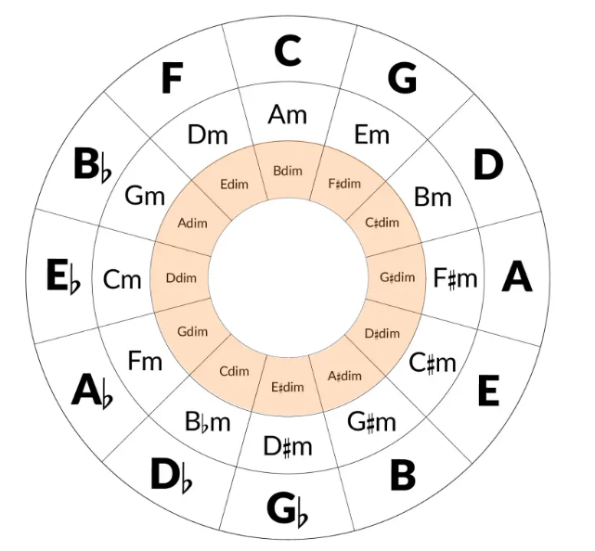

For the Chord Progression Network, all the chords were positioned in one of the 36 categories of the Circle of Fifths depending on their first three notes, for example A# and A#/A belong to the category A# because A#={A#,D, F} and A#/A={A#,D,F,A}. Some of the chords did not belong to any category, for those chords a new category is positioned in the center based on the name of the chord.

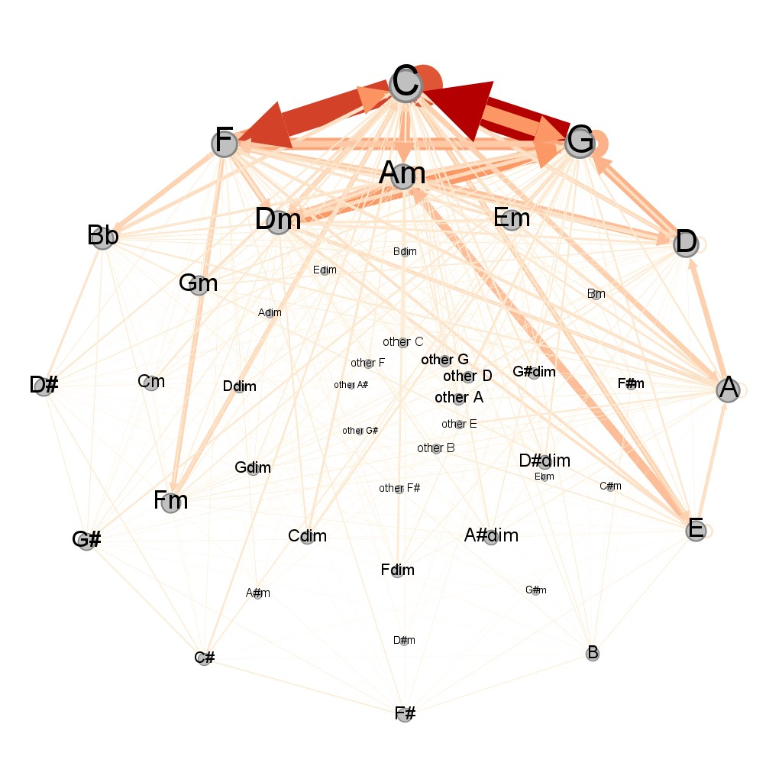

*Fig 7.4.2 Categories of Ray Charles Chord Progression Network Positioned in the Circle of Fifths, incorporating color and size to emphasize edge weights and node degrees.*

Conclusions:

* It is observed that the size of nodes changes between the circles and it is bigger for Major Chords. Major Chords are more commonly used than minor, diminished or other types of chords in Ray Charles Songs, Major Chords are associated with the feeling of happiness in music.
* Near the Key C, the weights of the connections are significantly higher compared to distant chords, then among all the songs there is a sensation of harmonization and similarity between the progression.
* For the outer and middle circle the degree is higher when approaching the key but for the inner circle the degree is higher when the chord is distant from the key. Then it implicates that diminished chords were preferred for Ray Charles to give contrast and tension to the songs
* In the outer circle there is a counter clockwise direction observed.
* The progression C-F-G-C, is one of the most famous progressions in music and it is observed in the Ray Charles Chord Progression Network.

1. Some hypothesis were made at the beginning of the project

* The order in the elements of a chord does not matter, then if two chords have the same set of elements in different order, the chord will be considered the same.
* Repetition is a common characteristic in music, and links are repeated several times within a song, in order to preserve weight and comprehend which links were repeated among all songs, only unique links were considered for each song.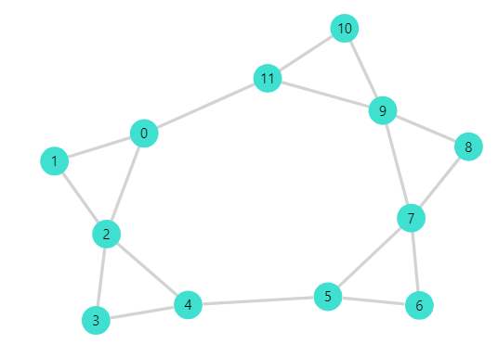
* All notes of songs form a star-shaped structure that could be present in a rotated state for each song, to preserve the relations between notes, all the structures were rotated to have the same orientation, this is called transposition of chords.

These hypotheses are considered in the interpretations of results.

**Results:**

1. **Failures in music:**

The high robustness of the graph explains why it is difficult to hear failures in music. The node failure is similar as when a musician is playing a song and the notes played in some chords are different from the expected, while link failures represent when a musician is playing a song and is incapable of making a chord progression between two chords.

Usually, when a person plays a wrong chord is more noticeable than when a person doesn't make the correct progression because there will be another link created to the subsequent chord. The graph also gives an idea of why several instruments playing together might form a very robust graph. This network connects several songs in one graph with the same key; it is similar to the idea of several instruments playing different melodies in the same key harmonizing together to interpret a sonic piece.

1. **Unique Music Style of Ray Charles:**

The small Jaccard similarity scores, and the low number of nodes and edges in the intersection, shows that the two networks are different. The similarity of neighboring common chords gives an idea of whether the chord progressions around these chords are similar or not. And they are very dissimilar in these two networks. This confirms that Ray Charles has a significant number of unique chord progressions.

Also, the comparison of inner circles of both Ray Charles and Ray Charles Jazz Genre networks with the General Jazz network showed that they share some similar chords but a significant number of them are different. Alongside this the common chords used by Ray Charles (one’s we saw in the inner circle) were major chords mostly. Based on these results we can conclude that Ray Charles has a unique style in his music.

1. **Ray Charles Preferences for Chords and Chord Progressions:**

Because the chords have been transposed to keys C and Am, it is not possible to say which exact chords are used commonly in his songs. Despite that, the Circle of Fifths analysis offers insights into a clear pattern for chord and chord progression choices.

When Ray Charles selects a key for song composition, the chosen key plays a pivotal role, typically close chords in the circle of fifths are used to enhance the song's harmony and incorporates distant diminished chords to introduce contrast. In this dataset, a noticeable inclination towards Major Chords over Minor or Diminished Chords has been observed.

1. **Communities and Homophily in the graph:**

As it was observed with the Louvain Algorithm and the Girvan Newman Clustering, there is only one community in the network, this is because chords were transposed but also the combination between any two chords is plausible with a small path between them. Sounds of chords resemble different colors, there are no rules governing chord matching, and chords are combined depending on the genre, and the musician's choices.

The concept of similarity in chords is subjective, in the circle of fifths similar chords are the ones who are close in the circle of fifths, in fact the average minimum distance of all the notes between two adjacent chords on the outer circle is 1. A higher amount of relations between close chords than between distant chords was observed, but the circle of fifths is not the only measurement to know the similarity between two chords.

The concept of homophily in chords is difficult to implement because there are many chords, but because there are only 12 notes in music, many chords could have common notes with many others. Only the first three notes were considered to belong in a certain category, and the order in the chord was not considered, then there is not a clear criteria to define homophily in chords.

**Acknowledgments**

We would like to express our sincere gratitude to the following individuals who guided us to the success of this project.

* Dr Edwin Nassiff
* Aida Tayebi
* Chathura Jayalath

**References**

1. Ada Zhang. (2009, June 4). The Framework of Music Theory as Represented with Groups. *University of Washington*. https://sites.math.washington.edu/~morrow/336_09/papers/Ada.pdf
2. Aric A. Hagberg, Daniel A. Schult and Pieter J. Swart, “Exploring network structure, dynamics, and function using NetworkX”, in Proceedings of the 7th Python in Science Conference (SciPy2008), Gäel Varoquaux, Travis Vaught, and Jarrod Millman (Eds), (Pasad. (2008, Aug). Exploring network structure, dynamics, and function using NetworkX. *Proceedings of the 7th Python in Science Conference (SciPy2008)*, (Pasadena, CA USA), pp. 11–15. https://networkx.org/documentation/networkx-2.2/citing.html
3. Bien, N., Carrol, H., & Ramachandran, N. (2018, Dec 9). Network Analysis of Chord Progressions in Rock and Jazz Music. *Stanford Network Analysis Project*. https://snap.stanford.edu/class/cs224w-2018/reports/CS224W-2018-94.pdf
4. Fuxman Bass, J. I., Diallo, A., Nelson, J., Soto, J. M., Myers, C. L., & Walhout, A. J. (2013). Using networks to measure similarity between genes: association index selection. *Nature methods*, 1169–1176. https://pubmed.ncbi.nlm.nih.gov/24296474/